# Lesson 40 单词讲解

1. hostess n. 女主人hostess host waitress waiter actress actor

goddess god

1. unsmiling adj. 不笑的，严肃的

smiling

1. tight adj. 紧身的 紧的

a tight dress tight shoes tight schedule

1. fix v. 凝视

Her eyes were fixed on her plate.

1. globe n. 地球global adj. global economy
2. despair n. 绝望in despair 处于绝望之中desperate adj.绝望 地

# Lesson 40 课文&语法讲解

1. Last week at a dinner party, the hostess asked me to sit next to Mrs. …

beside / by 紧挨着

1. Mrs. … was a large, unsmiling lady in a tight black dress. 穿着

3.She did not even look up when I took my seat (就座）beside her.

1. Her eyes were fixed … and in a short time, she was busy eating.

be busy doing sth.

be busy with sth.

1. I tried to make conversation. Make a conversation 也行
2. ‘A new play is coming to “The Globe” soon,’ … ‘Will you be seeing it?’

现在进行时可以表示确定要发生的将来

am/is/are + doing 现在进行时

will be doing 将来进行时

都表示确定要发生的将来，用哪个都行

1. ‘Will you be spending your holidays abroad this year?’
2. ‘Will you be staying in England?’
3. In despair, I asked her whether she was enjoying her dinner.
4. ‘Young man,’ she answered, ‘if you ate more and talked less, we would both enjoy our dinner.’

蓝色部分表示虚拟语气，因为说的这件事与事实不符。

if 虚拟条件句（虚拟语气）

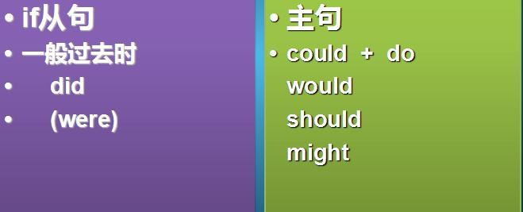If 虚拟条件句假设现在



1.I am not you, so I can’t make the decision.

1. You make the arrangements, so it will save us a lot of trouble.
2. I don’t know his phone number, so I won’t ring him up.

If I could rearrange the alphabet, I would put U and I together.

# Lesson 40 知识拓展

本课重点:

if 虚拟条件句（虚拟语气）

假设现在

If 虚拟条件句假设现在

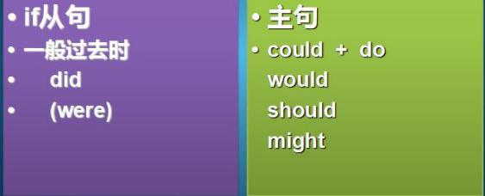

if 虚拟条件句 —— 假设现在

I am not a bird, so I can’t fly to you right away. If I were a bird, I could fly to you right away.

if 虚拟条件句 —— 假设现在

I don’t have superpower. I will not turn the time back. If I had superpower, I would turn the time back.

if 虚拟条件句 —— 假设现在

The baby is not hungry. It may not cry. If the baby were hungry, it might cry.

if 虚拟条件句 —— 假设现在

Look at the rocket! How fast it is!

If your tail were on fire, you would be that fast too.

本课重点:

if 虚拟条件句（虚拟语气） 假设现在